### **Urban Forestry Master Planning Workshop – Revised 6/19 SH**

**Dallas – June 24th**

Texas AgriLife Center

17360 Coit Rd

Dallas, TX

**“From the ground up”** is a term used in the Arboriculture industry. Trees mean money now and more importantly in the future. How trees can be utilized to build a healthy sustainable community will be addressed in this informative workshop.

* Whose trees are they
* Why trees matter
* Trees as tools

**“All work is done in accordance with ANSI A300 pruning standard”** This statement may appear in your proposals, contracts and specifications-but what does that really mean in practice. Whether you’re writing specifications for clients or evaluating a contractor’s pruning work, it’s essential to understand how to translate standards into clear, actionable language. This workshop will help you:

* Craft precise pruning specifications that align with ANSI A300 standards
* Identify proper terminology for various pruning objectives and methods
* Recognize acceptable pruning practices in the field
* Improve communication and accountability between planners, contractors, production arborist and clients.

Sharpen your understanding of pruning standards and elevate your urban forest management approach with practical, standards-based insight.

**8:00 – 8:30 AM** – Registration

**8:30 – 9:30 AM** – **Trees and Urban Forestry: The BIG Picture** – Dana Karcher- Project Developer at Davey Resource Group - The 3-30-300 rule. Human comfort zones. Green gentrification. What does this have to do with trees, and specifically trees in our communities? It’s time to move beyond the traditional thought that “trees are nice to have”. Trees are a necessity. And behavior motivations are the next stage in growing our urban forests and taking care of our trees. These tools and concepts are meant to influence our behaviors and attitudes around the growth of the urban forest and trees.

This talk will address competing priorities in communities that cause destruction and devaluing of our trees and urban forests. This includes a discussion on placemaking; elevating our cities to include trees as part of the identity of the community. We will also talk about engaging the community in the decisions around trees, all while helping to understand our motivation around growing a greener future. Collaboration is the key to our urban forest future. By looking at behaviors and attitudes around green infrastructure, we may find the solution to making trees a priority in Texas communities!

**9:30 – 10:30 AM** – **Nurturing Your Infrastructure-** Matt Grubisich, Consulting Manager, Texas Tree Surgeons **–** This presentation highlights the vital connection between urban design, public health, and sustainability. It emphasizes the importance of innovatively developing public rights-of-way to create healthier, more livable cities. By addressing the growing disconnect between communities and the natural environment, the presentation advocates for accessible, inclusive urban spaces that promote physical activity, well-being, and economic opportunity.  This presentation calls for bold, forward-thinking strategies to shape a healthier future for all.

Matt discusses the importance of community involvement in developing a sustainable urban forest as infrastructure. Trees are the only part of a cities infrastructure that will increase in value and Matt discusses what it takes to build a respected, valuable, and thus sustainable urban forest.

**10:30 AM – 10:45 AM -** *Break*

**10:45 - 11:45 AM** – *Introduction to ANSI A300 (2023) Pruning Standards –* Patrick Anderson, Director of Research & Arborologists**,** Rainbow Ecoscience

* Understanding the latest updates in ANSI A300 pruning standards
* Defining pruning objectives and their importance in tree health and risk management
* Overview of pruning systems which defines the long term form of the plant
* Importance of consistent pruning terminology for clear communication in specifications

**11:45 AM – 12:00 PM** – *Raffel and introductions*

**12:00 PM – 1:00 PM** – *Lunch and networking*

**1:00 - 2:00 PM** – *Pruning Systems, Objectives, Cuts, and Practices –* Kristoffer Rasmussen, TCIA Trainer, Ziggy ???, Owner, Knotty By Nature Tree Care

* Defining pruning systems and five vital elements
* Types of pruning cuts: reduction, removal, heading
* The science behind pruning and how it influences tree response and architecture
* Recognizing and managing pruning limitations based on tree condition and species

**2:00 – 3:00 PM** – *Writing Effective Pruning Specifications -* Kristoffer Rasmussen- TCIA Trainer, Ziggy ???, Owner, Knotty By Nature Tree Care

* Five vital elements of a pruning specification
* Defining terms and conditions
* Writing pruning specifications for multiple trees
* Group exercise: Reviewing and improving pruning specifications

**3:00 – 3:15 PM** – *Break* and Raffel

**3:15 – 4:00 PM** – *Field Application: Structural Pruning & Tree Architecture –* Kristoffer Rasmussen, TCIA Trainer, Ziggy ???, Owner, Knotty By Nature Tree Care

* On site visit to discuss and identify pruning strategies
* Identifying conditions of concern in young trees and making pruning decisions
* Practical application of structural pruning techniques
* Observing tree architecture and growth patterns to inform pruning strategies

 **Dana Karcher –** Project Developer at Davey Resource Group, President of International Society of Arboriculture **-** Experienced Program and Project Developer with a demonstrated history of working with municipalities, non-profit organizations, and utilities supporting them in managing their green infrastructure. Connector of those that believe that trees and the benefits that they provide make stronger and better communities. Inspiring speaker that convinces audiences that a well-managed community forest connects people to nature for the benefit of all humankind. Current ISA President.

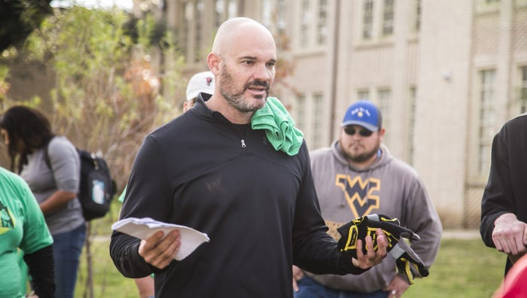 **Matt Grubisich –** Matt Grubisich – Matt recently joined the staff of Texas Tree Surgeons as their Consulting Manager. Previously he was with the City of Garland 2020 - 2025 as their Parks Director overseeing the maintenance and operations of over 2,500 acres of parks and open space. Previously Matt served as the Director of Operation for the Texas Trees Foundation for the past 10 years. He brings with him over 20 years of operational experience assisting communities prepare for future challenges by enhancing their capacity to implement resiliency projects to create vibrant healthy communities. Matt holds a Bachelor of Science in Urban Forestry from Iowa State University, is an ISA Certified Arborist, SAF Certified Forester, and has served in a leadership role on numerous local and state Boards and Commissions.

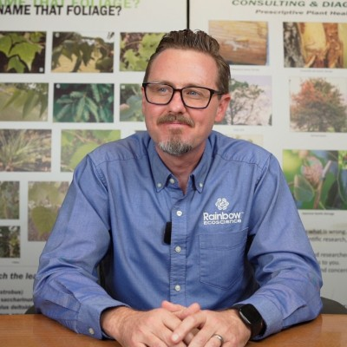 **Patrick Anderson –** Director of Research and Arborilogist at Rainbow Ecoscience - he provides plant healthcare protocol training and support for Rainbow’s clients nationwide. He has years of practical tree care experience, and conducts field research trials throughout the U.S., with emphasis on plant growth regulators and landscape scale management. Patrick frequently gives talks and guest lectures for green industry groups, and has authored numerous articles on tree and shrub care. Patrick has a B.S. in Forest Science from Penn State University, is an ISA Board-Certified Master Arborist and Municipal Specialist, ISA Tree Risk Assessment Qualified, an ASCA Registered Consulting Arborist, a North Carolina Licensed Landscape Contractor, and is currently a member of the Revision Subcommittee for the ANSI 300 Part 2 Soil Management. In addition, Patrick serves as a TreeMaster for TreesCharlotte.

 **Kristoffer Rasmussen** – Accreditation Auditor/TCIA Qualified Trainer – Krist has dedicated over 30 years to advancing tree care, safety training, and urban forest preservation. With experience as a municipal, commercial, and residential arborist, he shares insights and stories from a lifetime in the field. As a Certified Treecare Safety Professional, Certified Tree Climber, TCI Accreditation Auditor, and Red Cross CPR/First Aid Instructor, Kristoffer is committed to the safety and growth of arborists and their communities. He plays a pivotal role in assessing and accrediting tree care companies, driving them toward excellence and adherence to industry standards. His passion for sustainable practices and fostering collaboration makes him a respected leader and advocate in arboriculture.

**Gerzson Nyiri –** Owner, Knotty By Nature Tree Care – Ziggy has been a Certified Arborist since 2009 and performing high angle rope access and a rescue trainer since 2016. He has performed two actual high angle rescues under real life conditions. He holds multiple certifications for rope rescue through NATS, TCIA and others and has participated in the Texas Tree Climbing Championship since 2016 while also collaborating the San Antonio Speed Climb Event in 2025.